Domain Name System (DNS)

* The **domain name system (DNS)** is the Internet’s naming service that maps human-friendly domain names to machine-readable IP addresses.
* The service of DNS is transparent to users. When a user enters a domain name in the browser, the browser has to translate the domain name to IP address by asking the DNS infrastructure. Once the desired IP address is obtained, the user’s request is forwarded to the destination web server.

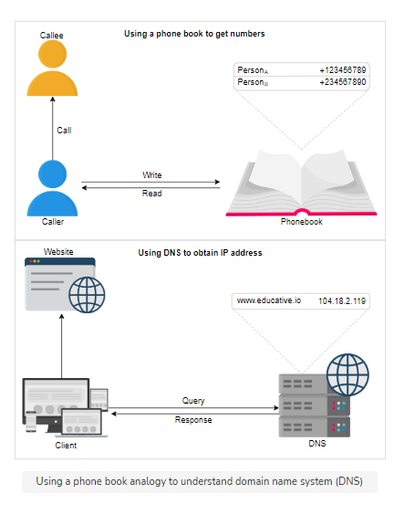

Important Details:

* **Name servers:** It’s important to understand that the DNS isn’t a single server. It’s a complete infrastructure with numerous servers. DNS servers that respond to users’ queries are called **name servers**.
* **Resource records:** The DNS database stores domain name to IP address mappings in the form of resource records (RR). The RR is the smallest unit of information that users request from the name servers.
* **Caching:** DNS uses caching at different layers to reduce request latency for the user.
* **Hierarchy:** DNS name servers are in a hierarchical form. The hierarchical structure allows DNS to be highly scalable because of its increasing size and query load.

DNS hierarchy:

* There are mainly four types of servers in the DNS hierarchy:
  1. DNS Resolver:
     + Resolvers initiate the querying sequence and forward requests to the other DNS name servers.
     + Typically, DNS resolvers lie within the premise of the user’s network. These servers can also be called local or default servers.
  2. Root-level name servers:
     + These servers receive requests from local servers. Root name servers maintain name servers based on top-level domain names, such as .com, .edu, .us, and so on.
  3. Top-level domain (TLD) name servers:
     + Top-level domain (TLD) name servers: These servers hold the IP addresses of authoritative name servers
  4. Authoritative name servers:
     + These are the organization’s DNS name servers that provide the IP addresses of the web or application servers.

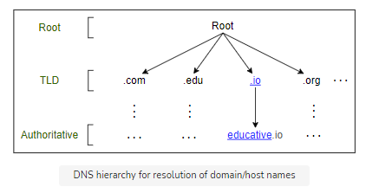

Caching:

* Caching refers to the temporary storage of frequently requested resource records. A record is a data unit within the DNS database that shows a name-to-value binding.
* Caching reduces response time to the user and decreases network traffic. When we use caching at different hierarchies, it can reduce a lot of querying burden on the DNS infrastructure.

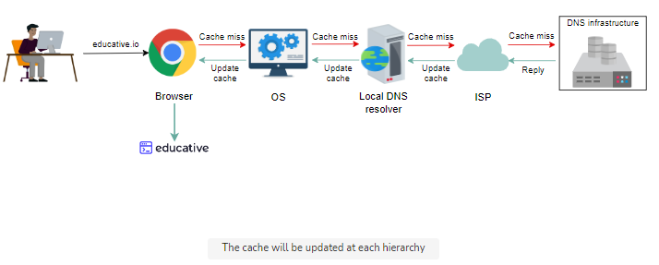

DNS as a distributed system:

* The distributed nature of DNS has the following advantages:
  + It avoids becoming a single point of failure (SPOF).
  + It achieves low query latency so users can get responses from nearby servers.
  + DNS is scalable, reliable, and consistent.
* Three main reasons make the DNS a reliable system: Caching, Server Replication, Protocol (DNS uses UDP, However, it can use TCP when its message size exceeds the original packet size of 512Bytes. This is because large-size packets are more prone to be damaged in congested networks.)
* DNS compromises on strong consistency to achieve high performance because data is read frequently from DNS databases as compared to writing. However, DNS provides eventual consistency and updates records on replicated servers lazily.
* Consistency can suffer because of caching too. Since authoritative servers are located within the organization, it may be possible that certain resource records are updated on the authoritative servers in case of server failures at the organization. Therefore, cached records at the default/local and ISP servers may be outdated. To mitigate this issue, each cached record comes with an expiration time called **time-to-live (TTL)**.